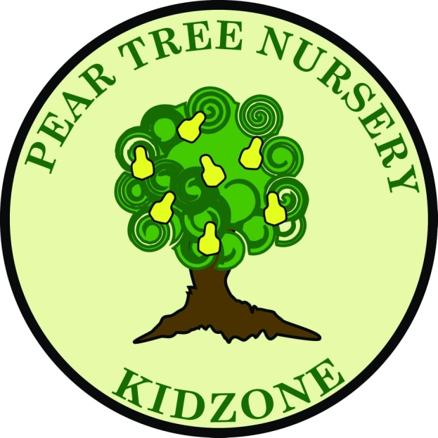 Kidzone and Holiday Club Bullying policy
Policy:

We take bullying very seriously. Bullying involves the persistent physical or verbal abuse of another child or children. It is characterised by intent to hurt, often planned, and accompanied by an awareness of the impact of the bullying behaviour.
A child who is bullying has reached a stage of cognitive development where he or she is able to plan to carry out a premeditated intent to cause distress to another. Bullying can occur in children five years old and over and may well be an issue in after school clubs and holiday schemes catering for slightly older children.

Procedure:

If a child bullies another child or children:
- we show the children who have been bullied that we are able to listen to their concerns and act upon them;
- we intervene to stop the child who is bullying from harming the other child or children;
- we explain to the child doing the bullying why her/his behaviour is not acceptable;
- we give reassurance to the child or children who have been bullied;
- we help the child who has done the bullying to recognise the impact of their actions;
- we make sure that children who bully receive positive feedback for considerate behaviour and are given opportunities to practise and reflect on considerate behaviour;
- we do not label children who bully as ‘bullies’;
- we recognise that children who bully may be experiencing bullying themselves, or be subject to abuse or other circumstances causing them to express their anger in negative ways towards others;
- we recognise that children who bully are often unable to empathise with others and for this reason we do not insist that they say sorry unless it is clear that they feel genuine remorse for what they have done. Empty apologies are just as hurtful to the bullied child as the original behaviour;
- we discuss what has happened with the parents of the child who did the bullying and work out with them a plan for handling the child's behaviour; and
- we share what has happened with the parents of the child who has been bullied, explaining that the child who did the bullying is being helped to adopt more acceptable ways of behaving.

This policy was adopted at a meeting of Pear Tree Nursery
Held on 03.01.2020
Date to be reviewed 03.01.2021
Signed on behalf of the provider
Name of signatory
Role of signatory (e.g. chair, director or owner)

